**Lab 1: Hello World                Date: 03/02/2020**

**Exercise 1: Types**

**Question**: Using the “Hello World” program as a starting point, write a program that prints out the size in bytes of each of the fundamental data types in C++.

**Solution**:

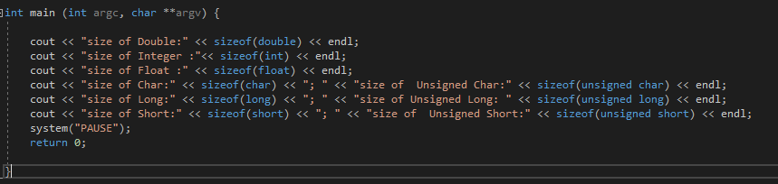

**Sample Output:**

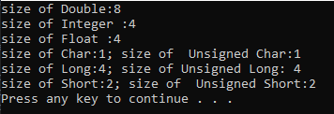

**Exercise 2: Floating point Precision**

**Question:**

How small does y have to be before you get a “divide by zero” error?  Does the value of x affect the result?

**Solution:**